Navigating CIO’s Future of Work Event
Your profile isn’t just information about you. It contains any bookmarks you make to revisit people and sponsors, the sessions you add to your schedule, your customized time zone, and more. We recommend you add a photo and select your interest areas so people can reach out to you with their common interests.
Click here to open your profile. This button is found on the upper right on your screen.

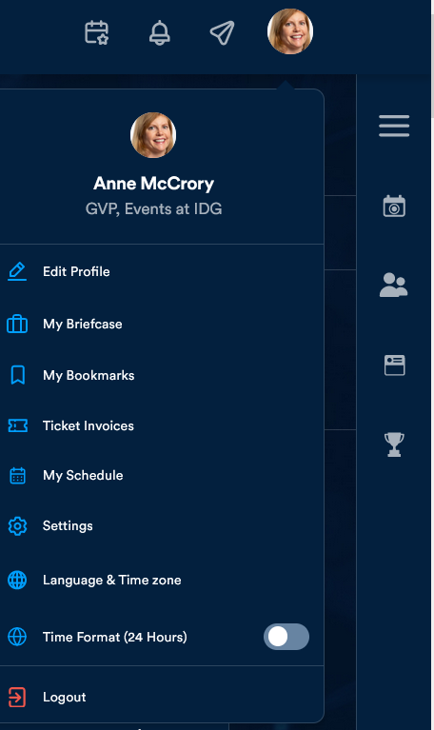

The main navigation is at the top of the screen. The hamburger at right provides you with icons for What’s Happening Now, People, Event Feed and the Leaderboard.
Use the hamburger to
display the sub-nav to
see features such as
People, Event Feed and
Main navigation the Leaderboard.
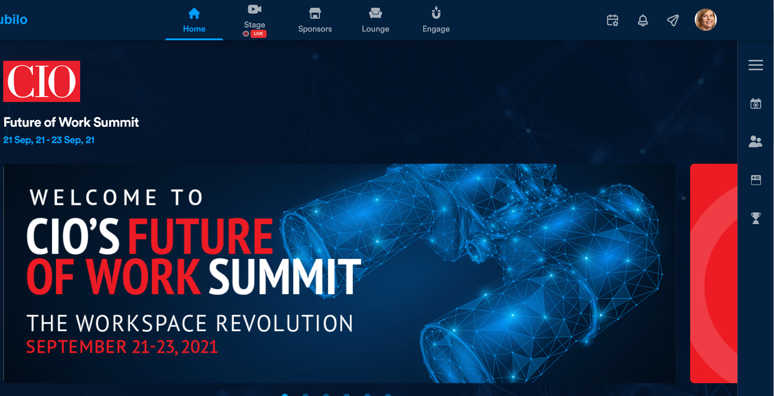

When you expand the hamburger, first you’ll see What’s Happening Now. Next is the People tab, which shows you speakers – you can view their profiles – as well as all attendees. Click on a profile to send a text message (“chat”) or meeting request (“meet”) to any attendee (we recommend you chat people first, then invite them to meet when they respond). Use the icons as shown below to sort by alpha order or filter based on interest area, job title, company, geo, and industry.
To focus on who is live in the environment, expand the attendee view and switch on “Show Online Attendees” (see next screenshot). A green dot will appear next to each person who is logged in.

Expand view here to
turn on switch to see
who is live in the event.

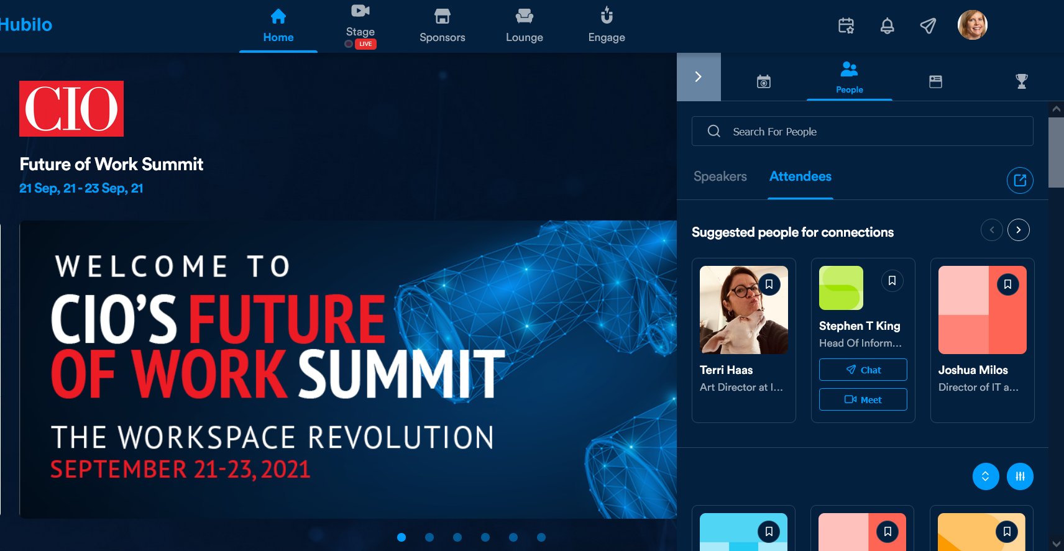

Use these buttons to
sort and filter attendees.

The Expanded people view looks like this. Note where to switch on “Find Online Attendees.” On this screen, as on others, you can bookmark people and sponsors to visit later. Click on the ribbon icon as shown to add it to your bookmarks, which are stored in your profile.

Click this icon to add a person or sponsor to add it to your Bookmarks to revisit later. Bookmarks are in your profile.

